Perfect 👍 You prefer a clear, structured format — with
✅ Requirement, 🔍 Explanation, and 🧠 Example.
Here’s your full detailed answer on “Requirements of Message Authentication” in the same easy-to-write, exam-friendly format 👇

Requirements of Message Authentication
Message authentication ensures that communication between sender and receiver is secure, genuine, and free from tampering.
The main requirements are Message Integrity, Authentication of the Sender, Non-Repudiation, and Resistance to Replay Attacks.

1. Message Integrity
✅ Requirement:
The receiver must be able to confirm that the contents of the message have not been changed, deleted, or inserted during transmission.
🔍 Explanation:
When a message is sent, it may pass through many intermediate nodes or networks.
An attacker could intercept and alter the message contents or modify certain parts.
Message authentication ensures that even a small change in the data, such as a single-bit alteration, is detected by the receiver.
It guarantees that the data received is exactly the same as what was sent.
🧠 Example:
If Alice sends the message “Transfer ₹10,000” to Bob, and an attacker changes it to “Transfer ₹100,000”, the authentication mechanism should detect this alteration immediately.
Techniques like Message Authentication Code (MAC) or Hash-based Message Authentication Code (HMAC) are used to ensure integrity.

2. Authentication of the Sender (Source Authentication)
✅ Requirement:
The receiver must be able to verify that the message was truly sent by the claimed sender and not by an impersonator.
🔍 Explanation:
Attackers may try to masquerade as legitimate users and send fake messages.
Source authentication ensures that the identity of the sender is genuine and that the message did not originate from a fraudulent source.
This requirement builds trust between communicating parties and prevents unauthorized message injection.
🧠 Example:
If an attacker pretends to be a bank official and sends “Update your account details” to a customer, the authentication system should detect that the message did not actually come from the bank.
This can be achieved using digital certificates, digital signatures, or shared secret keys between sender and receiver.

3. Non-Repudiation
✅ Requirement:
The sender should not be able to deny having sent a message once it has been transmitted.
Similarly, the receiver should not be able to deny having received it when proof is available.
🔍 Explanation:
Non-repudiation provides legal evidence that a particular entity indeed participated in a communication.
It ensures accountability by preventing either party from denying their involvement.
This is vital in online transactions, contracts, and secure email communication where the authenticity of messages may later be used as proof.
🧠 Example:
If Alice digitally signs a message “I agree to pay ₹5,000” and sends it to Bob, she cannot later claim that she never sent the agreement.
Digital signatures based on public-key cryptography are widely used to provide non-repudiation.

4. Resistance to Replay Attacks (Timeliness or Message Freshness)
✅ Requirement:
The system must ensure that an attacker cannot resend a previously valid message to trick the receiver into accepting it again.
🔍 Explanation:
Replay attacks occur when an attacker captures a legitimate message and retransmits it at a later time to gain unauthorized access or perform duplicate actions.
To counter this, authentication systems must verify the freshness or timeliness of each message.
This is done using unique identifiers like timestamps, sequence numbers, or nonces (random numbers used once).
🧠 Example:
If a user sends a valid login message at 10:00 AM, and an attacker replays the same login message at 10:10 AM, the system should detect it as invalid because it lacks freshness.
By including timestamps or nonces, the receiver can confirm that the message is recent and not a replayed one.

Confidentiality (Optional but Important)
✅ Requirement:
Although authentication mainly ensures integrity and authenticity, sometimes the message must also remain secret.
🔍 Explanation:
Attackers might perform traffic analysis or disclosure attacks to learn sensitive data even if they can’t alter it.
🧠 Example:
In military or medical communication, authentication and confidentiality are used together to ensure both secrecy and trustworthiness.
🔐 Mechanisms Used:
- Encryption (symmetric or asymmetric) along with authentication.

Conclusion
Message authentication is crucial to ensure secure digital communication.
The major requirements — Message Integrity, Sender Authentication, Non-Repudiation, and Resistance to Replay Attacks — work together to protect against modification, impersonation, and replay threats.
By meeting these requirements, communication systems can ensure both the trustworthiness and security of exchanged messages.

Message Authentication Functions
Message authentication functions are designed to verify both the integrity of a message and its origin.
Three types:
Hash function
Mac
Msg encryption

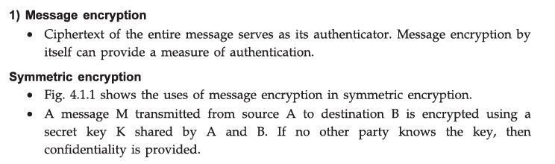
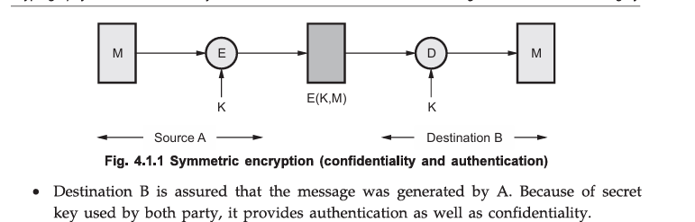

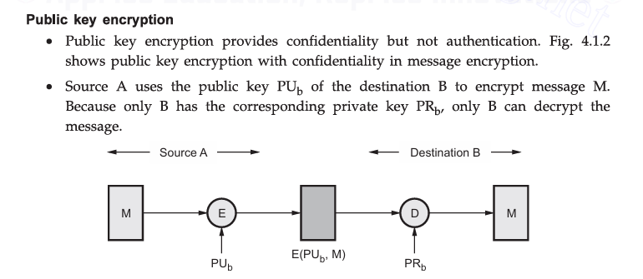

Only B can decrypt the message → Confidentiality achieved
But no authentication, because anyone (even an attacker) can use B’s public key to send a message claiming to be A.

In Case 3, both confidentiality and authentication are achieved because the sender A first encrypts the message M with A’s private key (PR_A), providing authentication and a digital signature, and then encrypts the result with the receiver B’s public key (PU_B), providing confidentiality. Thus, only B can decrypt the message using PR_B, and only A could have created it using PR_A, ensuring confidentiality, authentication, integrity, and non-repudiation.
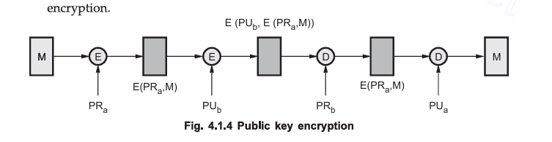

Message Authenticcation Code:
A Message Authentication Code (MAC) is a short fixed-length value generated from a MAC function that takes a message and a secret key as input and produces a unique code.
It ensures that the message is authentic and unchanged, since only the sender and receiver, who share the same secret key, can generate or verify the correct MAC.
It is used to verify both the integrity and authenticity of the message — ensuring that:
- Integrity: The message has not been changed during transmission.
- Authenticity: The message was sent by someone who knows the shared secret key.

1. Message Authentication Through Symmetric Encryption
In symmetric encryption, the same key is used for both encryption and decryption. While symmetric encryption is mainly designed for confidentiality, authenticated encryption schemes combine encryption and message authentication in one step.

Only the sender and receiver, who share the secret key, can generate or verify the correct MAC.
Simple Example
Suppose:
- Sender (Alice) and Receiver (Bob) share a secret key:
- Key = "ABC123"
- Message to send:
- Message = "Pay Rs.5000 to Bob"
Now, Alice creates a MAC using a formula like:
MAC = Hash(Key + Message)
So Alice computes:
MAC = Hash("ABC123Pay Rs.5000 to Bob")
Let’s say the result is:
MAC = "X9F7A2"
Alice sends both to Bob:
Message: Pay Rs.5000 to Bob
MAC: X9F7A2

✅ On Bob’s Side (Verification)
Bob also knows the same Key = "ABC123".
He computes:
MAC’ = Hash("ABC123Pay Rs.5000 to Bob")
If Bob’s computed MAC’ = X9F7A2 (same as received),
then Bob knows:
- The message was not changed (Integrity ✅)
- The message was sent by Alice, who knows the key (Authenticity ✅)
If a Hacker Tries to Modify
- If a hacker changes message → "Pay Rs.9000 to Hacker"
They don’t know the secret key, so they can’t create a correct MAC.
When Bob checks, the MAC won’t match → message is rejected

2. Message Authentication in Public-Key Cryptography
In public-key cryptography (asymmetric encryption), encryption and decryption can also be used to provide message authentication, though typically with digital signatures rather than just encryption alone.
Digital Signatures for Authentication
In this case, the sender uses their private key to sign a message (or a hash of the message). The process is as follows:
- Message Signing:
  - The sender computes the hash of the message (a fixed-length digest).
  - The sender then encrypts the hash with their private key, producing a digital signature.
- Message Transmission:
  - The sender sends the original message along with the digital signature to the receiver.
- Verification:
  - The receiver computes the hash of the received message and decrypts the digital signature using the sender's public key.
  - If the decrypted signature matches the computed hash, it confirms that the message:
    - Has not been altered (integrity),
    - Was signed by the sender (authenticity).

Hash Function
A hash function is a mathematical algorithm that takes an input message of any length and converts it into a fixed-length output, called a hash value or message digest.
It is a one-way function, meaning it’s easy to compute the hash from the message, but impossible to get the original message back from the hash.
2. Properties of a Good Cryptographic Hash Function
A good cryptographic hash function must possess the following properties:
2.1. Deterministic
- The same input always produces the same output hash.
2.2. Fixed Size Output
- Regardless of the input size, the output (hash) is always of a fixed size (e.g., SHA-256 always produces a 256-bit hash).
2.3. Fast Computation
- The hash function should be computationally efficient to compute.
2.4. Pre-image Resistance
- Given a hash value $h$, it should be computationally infeasible to find any input $x$such that $H(x)=h$. In other words, it should be hard to reverse the hash function.
2.5. Collision Resistance
- It should be computationally infeasible to find two different inputs $x$and $y$such that $H(x)=H(y)$. A hash function with poor collision resistance is vulnerable to birthday attacks.
2.6. Avalanche Effect
- A small change in the input should result in a significantly different output. This ensures that even small alterations in the input lead to completely different hash values.

The following figure illustrates a variety of ways in which a hash code can be used to provide message authentication, as follows.
a) Encrypt message plus hash code
In this method, the message (M) and its hash code H(M) are concatenated and then encrypted together using a shared secret key (K).
This provides confidentiality, because only the sender and receiver know the key, and also provides authentication, since the hash code is protected within the ciphertext.
Thus, both message secrecy and integrity are ensured.
➡️ Provides: Confidentiality + Authentication + Integrity
➡️ Notation: $E_{K}[M+H(M)]$ fig:a
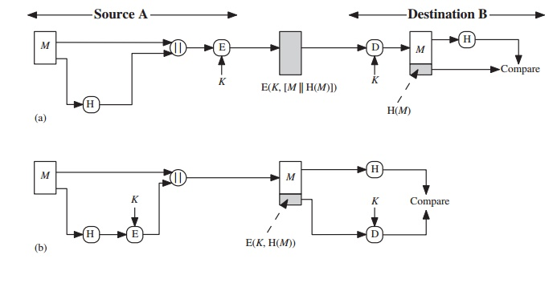
b) Encrypt hash code with shared secret key
In this approach, only the hash code H(M) is encrypted using the symmetric key (K), while the message M itself is sent in plaintext.
This method provides authentication and integrity (since only the sender and receiver can produce or verify the encrypted hash), but it does not provide confidentiality of the message.
c) Encrypt hash code with sender’s private key
Here, the sender A uses their private key (PR_A) to encrypt the hash code H(M), producing a digital signature.
The receiver (or anyone) can verify the signature using A’s public key (PU_A).
This provides authentication, integrity, and non-repudiation, since only A could have generated the signature using A’s private key.
If confidentiality is also required, the entire message (and signature) can later be encrypted using the receiver’s public key.
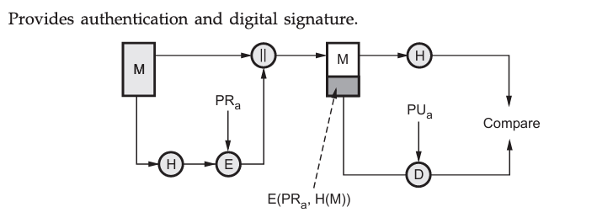

Process of hash function:
- Input Message Division:
The original message (M) is divided into fixed-size blocks (for example, 512 bits each).
Example: Message = “HELLO WORLD” → divided into chunks of 512 bits.
- Padding:
If the message doesn’t fit exactly into these block sizes, padding bits are added to fill up the last block.
Padding often includes a ‘1’ bit followed by zeros and sometimes a length field at the end.
Purpose: To make total message length a multiple of the block size.
- Iterative Hashing (Compression Function):
Each message block is processed one at a time through a compression function (the core of the hash algorithm).
The compression function mixes the bits and produces an intermediate hash value after each round.
- Bitwise Operations:
Inside each compression step, mathematical and logical operations like:
  - XOR (⊕)
  - AND, OR
  - Bit shifts and rotations
are performed to ensure diffusion and confusion (spreading input bits widely).
- Final Output:
After all blocks are processed, the final result is a fixed-size hash value H(M).
Example:
  - Input: “Hello World”
  - Output (SHA-256): a591a6d40bf420404a011733cfb7b190... (256-bit digest)

Security Considerations for Hash Functions
The strength of a cryptographic hash function depends on how resistant it is to various types of attacks. Below are the primary attacks that cryptographic hash functions are designed to resist:
Collision Attack
A collision occurs when two different inputs produce the same hash output. A hash function with weak collision resistance can be exploited by attackers to substitute one message for another without detection.
- Example: If an attacker finds two different messages $M_{1}$and $M_{2}$such that $H(M_{1})=H(M_{2})$, then the attacker can replace $M_{1}$with $M_{2}$without detection.
To resist collisions, the hash function must have strong collision resistance. SHA-2 and SHA-3 are designed to resist such attacks, while MD5 and SHA-1 are now considered vulnerable.
Pre-image Attack
A pre-image attack occurs when an attacker is given a hash value $h$and tries to find an input $x$such that $H(x)=h$. A good cryptographic hash function should make it computationally infeasible to reverse the hash and find the original input
- without invalidating the signature.
Avalanche Effect
- The avalanche effect refers to the property that a small change in the input should produce a drastically different output hash. A secure hash function exhibits the avalanche effect, meaning even a tiny modification (e.g., flipping one bit) in the input message should result in a completely different hash value.
- Importance: This property ensures that the hash function is unpredictable and resistant to attacks that try to exploit patterns in the input data.
Vulnerabilities in Hash Functions
- Historically, hash functions like MD5 and SHA-1 were widely used, but over time, both were found to be vulnerable to collision attacks:
  - MD5: Vulnerable to collision attacks after $2^{64}$operations.
  - SHA-1: Vulnerable to collision attacks after $2^{80}$operations (SHA-1 is now considered broken due to weaknesses exposed by researchers).
- As a result, modern cryptographic protocols have moved to using SHA-2 and SHA-3, which are more resistant to collisions and other cryptographic weaknesses.

The Birthday Attack on Hash Functions
The birthday attack takes advantage of the birthday paradox to find two different inputs that hash to the same value. The probability of finding a collision grows rapidly with the number of inputs that are hashed, meaning that even with a relatively small number of attempts, an attacker can find two inputs that hash to the same value.
Concept of the Birthday Attack
- A cryptographic hash function with an output size of $n$bits has a possible output space of $2^{n}$possible hash values.
- The birthday attack works by finding two distinct messages that hash to the same value, $H(M_{1})=H(M_{2})$.
- The key observation is that to find a collision, the attack doesn’t need to try all possible input values (which would require $2^{n}$trials). Instead, the number of trials needed to find a collision is roughly $2^{n/2}$, which is much smaller than $2^{n}$.
This reduction in the number of attempts is due to the probability distribution of hash values: after hashing a large number of distinct inputs, it becomes more likely that some of them will collide.
How the Birthday Attack Works
Simplified Explanation with an Example
Let’s assume we are dealing with a hash function that produces an output of 3 bits (just for simplicity). The hash function can therefore have 8 possible output values (since $2^{3}=8$).
- Suppose we hash 4 distinct messages (M1, M2, M3, M4).
- Each message is hashed into one of the 8 possible output values.
- We now have the following possible outcomes:
  - $H(M_{1})=110$
  - $H(M_{2})=011$
  - $H(M_{3})=101$
  - $H(M_{4})=110$
- In this case, we observe that M1 and M4 have the same hash output $H(M_{1})=H(M_{4})=110$. This is a collision.

Probability of Finding a Collision
In the above example, we only needed to hash 4 messages to find a collision out of a possible 8 hash outputs. With more bits, the number of required messages grows significantly, but it remains far smaller than $2^{n}$.
- Birthday Bound: The birthday paradox shows that for an $n$-bit hash, the number of hashes required to find a collision with a probability of at least 50% is approximately $2^{n/2}$trials.
Example: Birthday Attack in Practice
Let's say an attacker is targeting SHA-1 (160-bit output), which is vulnerable to birthday attacks.
- Step 1: The attacker collects a large set of messages, hashes them, and stores the results.
- Step 2: Using the birthday paradox, the attacker compares these hashes to find two distinct messages $M_{1}$and $M_{2}$that produce the same hash output $H(M_{1})=H(M_{2})$.
- Step 3: The attacker then replaces the original message with the forged message $M_{2}$, and the system verifies the hash as valid.
If the system relies solely on the hash for integrity (without using signatures, keys, or additional checks), the attacker can successfully tamper with the data without detection.
Security of Message Authentication Code (MAC)
A Message Authentication Code (MAC) is a cryptographic technique used to ensure message integrity and authentication between two communicating parties.
It uses a shared secret key between the sender and receiver to generate a small block of data, called the MAC value or tag, which is appended to the message.
The receiver, using the same secret key, recalculates the MAC on the received message and compares it with the received tag.
If both match, the message is considered authentic and unmodified.

🔸 Objective of MAC Security
The main goal of a MAC is to provide security against forgery and modification of data.
A secure MAC ensures that:
- Only parties possessing the secret key can generate or verify a valid MAC.
- An attacker cannot alter the message or generate a new valid MAC without knowing the key.
- It is computationally infeasible to find two messages that have the same MAC value (collision resistance).

🔸 Security Requirements of MAC
To be considered secure, a MAC must satisfy the following properties:
1. Resistance to Key Recovery
An attacker should not be able to determine the secret key $K$even after observing multiple message–MAC pairs.
The MAC function must hide all information about $K$.

2. Forgery Resistance
Even if an attacker knows several valid (Message, MAC) pairs, it should be computationally infeasible to produce a valid MAC for any new message that has not been seen before.
This ensures that attackers cannot impersonate the legitimate sender.

3. Collision Resistance
It must be very difficult to find two different messages $M_{1}$and $M_{2}$such that:
$$MAC(K,M_{1})=MAC(K,M_{2})$$
This prevents attackers from replacing a message with another one that gives the same MAC.

4. Dependence on Secret Key
The MAC must depend on the secret key as well as on the entire message content.
If the key or part of the message is changed, the MAC output should change completely.

5. Resistance to Replay Attacks
The MAC should be combined with timestamps, sequence numbers, or nonces so that a valid message cannot be captured and resent later by an attacker.

🔸 Security Strength of MAC
The strength or security of a MAC depends on:
- The length of the key (K) – longer keys provide stronger security (typically 128 bits or more).
- The design of the MAC algorithm – must be cryptographically secure (e.g., HMAC, CMAC).
- The underlying hash or cipher function – should not be vulnerable to known cryptographic attacks (avoid MD5 or SHA-1).
.2 Introduction to Message Authentication Codes (MACs)
A Message Authentication Code (MAC) is a cryptographic value used to verify the integrity and authenticity of a message. It serves two purposes:
- Integrity: Ensures that the message has not been altered in transit.
- Authenticity: Verifies that the message was generated by a legitimate sender.
The MAC is generated using a secret key shared between the sender and the receiver. This key ensures that only the parties who possess the key can authenticate the message.
2. How MAC Works
A MAC is created by applying a cryptographic hash function or block cipher to the message and a secret key. The result is a fixed-length output, which is the MAC. This MAC is then sent along with the original message.
Steps in Generating a MAC:
- The sender and receiver share a secret key (K).
- The sender computes the MAC by applying the MAC function (which uses the secret key and the message).
- The sender sends both the message and the MAC to the receiver.
- The receiver uses the same MAC function, the shared key, and the received message to compute a MAC.
- If the computed MAC matches the received MAC, the message is verified to be authentic and intact.
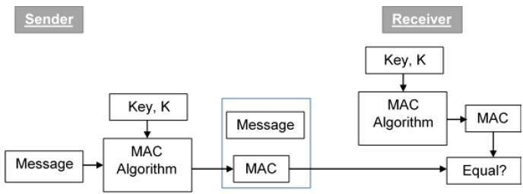
Sender's side: The message $M$and the secret key $K$are input to the MAC function. The MAC is generated.
Receiver's side: The receiver uses the same key $K$and computes the MAC from the received message. If the computed MAC matches the transmitted MAC, the message is authentic and has not been altered.
Properties of a Good MAC
For a MAC to be effective, it must have the following properties:
- Uniqueness: A MAC must be unique for each message. No two distinct messages should have the same MAC under the same key.
- Unforgeability: An attacker should not be able to forge a valid MAC without knowing the secret key.
- Integrity: Any modification to the message should result in a different MAC.
- Efficiency: The MAC generation and verification process should be fast and computationally efficient.
Uses of MACs
MACs are used in various cryptographic protocols for ensuring both the integrity and authenticity of data. Some common applications include:
- TLS/SSL: For securing web communication, MACs are used to verify that the transmitted data has not been altered.
- IPsec: In secure IP communication, MACs are used to authenticate the data packets.
- Wireless Networks: MACs are used to authenticate messages in protocols like WPA2 (Wi-Fi Protected Access 2).
7. Advantages and Disadvantages of MACs
Advantages:
- Efficiency: MACs are generally fast to compute and verify.
- Security: Provides strong message integrity and authenticity when implemented with strong cryptographic primitives like hash functions or block ciphers.
- Simplicity: Easier to implement than full digital signatures and can be used in environments where computational resources are limited.
Disadvantages:
- Key Distribution Problem: The sender and receiver must securely share the secret key.
- Vulnerability to Key Compromise: If the secret key is exposed, all future message authenticity is compromised.
Perfect 👍 — here’s a detailed, full-mark explanation (10–12 marks) of the SHA (Secure Hash Algorithm) suitable for exams like Cryptography & Network Security or Computer Networks.
It includes — definition, working, structure, properties, and applications, exactly how examiners expect.

🔹 Secure Hash Algorithm (SHA) – Detailed Explanation

🔸 1. Introduction
The Secure Hash Algorithm (SHA) is a family of cryptographic hash functions developed by the U.S. National Security Agency (NSA) and published by NIST (National Institute of Standards and Technology).
SHA is widely used in digital security applications such as digital signatures, message authentication, and data integrity verification.
It converts an input message of any length into a fixed-length hash value (message digest).
This digest acts as a unique digital fingerprint for the original data.

🔸 2. Purpose of SHA
SHA ensures three primary security objectives:
- Data Integrity – Any change in the message will produce a completely different hash.
- Authentication – Verifies that the message came from a trusted source.
- Non-repudiation – When combined with digital signatures, ensures the sender cannot deny sending the message.

🔸 3. SHA Family Overview
Version | Digest Length (bits) | Status / Remarks
SHA-0 | 160 | Withdrawn due to flaws.
SHA-1 | 160 | Insecure; broken by collision attacks.
SHA-2 | 224, 256, 384, 512 | Strong and widely used.
SHA-3 | 224, 256, 384, 512 | Latest version; based on Keccak algorithm.

🔸 4. Working of SHA Algorithm
Let’s take SHA-1 / SHA-256 as an example — all SHA versions follow similar steps with some variations.
Step 1: Message Padding
- The message is padded so that its length is congruent to 448 mod 512 (i.e., 64 bits short of a multiple of 512).
- Padding is done by:
  - Adding a single ‘1’ bit.
  - Adding ‘0’s until 64 bits remain.
  - Appending a 64-bit representation of the original message length.
Purpose: Ensures message divides evenly into 512-bit blocks.

Step 2: Message Parsing
- The padded message is divided into 512-bit blocks.
- Each block is processed one at a time.

Step 3: Initialization
- SHA uses fixed initial hash values (H0–H7).
- Example for SHA-256:
- H0 = 6a09e667
- H1 = bb67ae85
- H2 = 3c6ef372
- H3 = a54ff53a
- H4 = 510e527f
- H5 = 9b05688c
- H6 = 1f83d9ab
- H7 = 5be0cd19

Step 4: Processing (Compression Function)
For each 512-bit block:
- The block is divided into 16 words of 32 bits each.
- These are expanded to 64 words using logical operations (rotations, shifts, XOR).
- The algorithm then performs 64 rounds of mathematical operations on these words.
Each round uses:
- Bitwise operations: AND, OR, XOR, NOT.
- Modular addition: (mod 2³²).
- Constants (K[t]): Predefined per round.
Intermediate variables (a, b, c, d, e, f, g, h) are updated in every round.

Step 5: Output
After all message blocks are processed:
- The final hash values ( H0, H1, H2, ... ) are concatenated.
- The result is the final message digest (e.g., 256 bits for SHA-256).

🔸 5. Example (Conceptual)
If message = "HELLO"
After processing:
SHA-1("HELLO") = f7ff9e8b7bb2e09b70935a5d785e0cc5d9d0abf0
This fixed 160-bit output is completely different if even one letter changes (due to avalanche effect).

🔸 6. Properties of SHA
- One-way Function
  - It is computationally infeasible to recover the original message from its hash.
- Collision Resistance
  - It’s hard to find two different messages with the same hash.
- Avalanche Effect
  - Small changes in input → large unpredictable changes in output.
- Fixed Output Length
  - Regardless of message size, SHA always produces a fixed-size digest.
- Efficiency
  - Can process large messages quickly in blocks.

🔸 7. Security of SHA Versions
- SHA-1 – 160-bit digest, now considered insecure (collision found by Google’s SHAttered project in 2017).
- SHA-2 – More secure; uses longer digests (256/512 bits).
- SHA-3 – Based on the Keccak algorithm, resistant to length extension and other modern attacks.

🔸 8. Applications of SHA
Application | Purpose
Digital Signatures | Hash message before signing to ensure integrity.
Message Authentication Codes (HMAC) | Combine SHA with secret keys for secure authentication.
Password Storage | Hash passwords before saving in databases.
Blockchain | Bitcoin uses SHA-256 to link blocks securely.
SSL/TLS | Secure web communication.
File Integrity Checking | Verify file downloads using published SHA checksums.

🔸 9. Advantages
- Provides strong data integrity.
- Ensures tamper detection.
- Efficient for large data sets.
- Resistant to brute-force attacks when using SHA-2/SHA-3.

🔸 10. Limitations
- Older versions (SHA-1, SHA-0) are vulnerable to collision attacks.
- Computationally heavy for low-powered devices.
- Not suitable for password hashing alone (should be used with salts or KDFs like PBKDF2, bcrypt).

🔸 11. Summary Diagram (Conceptual)
Input Message → Padding → Divide into 512-bit Blocks → Compression Function → Final Hash Value

🔸 12. Conclusion
The Secure Hash Algorithm (SHA) is a family of cryptographic functions that generate a fixed-length, unique hash value from any input data.
It ensures integrity, authentication, and non-repudiation in modern cryptographic systems.
SHA-2 and SHA-3 are currently the recommended standards for secure hashing in digital security applications.

Would you like me to give a labeled diagram of the SHA process (for notebook or exam drawing) next? It helps get full marks in long-answer questions.

Digital Signatures
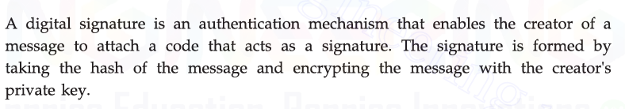
Requirements
Message authentication protects two parties who exchange messages from any third party. However, it does not protect the two parties against each other. Several forms of dispute between the two are possible. It must have the following properties
- It must verify the author and the date and time of the signature.
- It must authenticate the contents at the time of the signature.
- It must be verifiable by third parties, to resolve disputes.
Based on these properties, we can formulate the following requirements for a digital signature:
- The signature must be a bit pattern that depends on the message being signed.
- The signature must use some information unique to the sender, to prevent both forgery and denial.
- It must be relatively easy to produce the digital signature.
- It must be relatively easy to recognize and verify the digital signature.
- It must be computationally infeasible to forge a digital signature, either by constructing a new message for an existing digital signature or by constructing a fraudulent digital signature for a given message.
- It must be practical to retain a copy of the digital signature in storage.
Direct Digital Signature
The direct digital signature involves only the communicating parties (source, destination). It is assumed that the destination knows the public key of the source. A digital signature may be formed by encrypting the entire message with the sender's private key or by encrypting a hash code of the message with the sender's private key. Confidentiality can be provided by further encrypting the entire message plus signature with either the receiver's public key (public-key encryption) or a shared secret key (symmetric encryption). Note that it is important to perform the signature function first and then an outer confidentiality function.
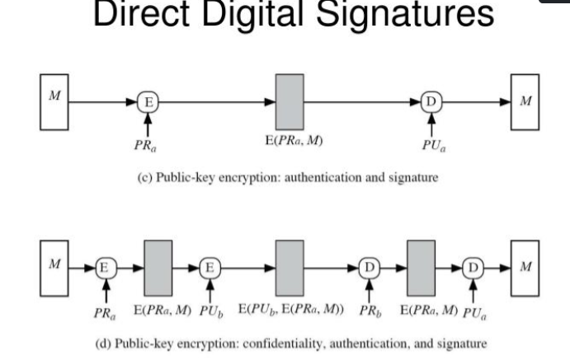
In case of dispute, some third party must view the message and its signature.

Weakness: Dependence on Sender’s Private Key Security
. The validity of the scheme depends on the security of the sender's private key. If a sender later wishes to deny sending a particular message, the sender can claim that the private key was lost or stolen and that someone else forged his or her signature

Administrative Controls to Reduce Risk
To minimize this threat, some management and security policies are followed:
- Timestamping:
  - Each signed message includes a date and time.
  - This ensures that even if a key is stolen later, signatures before that time can still be trusted.
- Prompt Reporting of Key Compromise:
  - Users must immediately report if a key is lost or stolen.
  - The key is then revoked by a Certificate Authority (CA).
  - After revocation, any new messages signed with that key are invalid.
- Key Management Systems:
  - Use of secure hardware (like Hardware Security Modules) to protect private keys.
  - Periodic key rotation and renewal.

What is an Arbitrated Digital Signature?
An Arbitrated Digital Signature is a type of digital signature scheme in which a trusted third party—called the arbiter—plays an active role in verifying and authenticating digital signatures between two communicating parties (sender and receiver).
In simple words:
It’s a digital signature process where a trusted middleman (arbiter) ensures the signature is valid, prevents fraud, and resolves disputes.

🔹 Why We Need an Arbiter
In direct digital signature schemes (like when Alice signs and sends a message directly to Bob using her private key):
- If Alice’s private key is later stolen, she can deny that she sent a message (“I didn’t send that; my key was stolen!”).
- There is no independent proof that Alice indeed signed the message at that time.
To solve this, we add an arbiter, a trusted authority who helps ensure:
- Authenticity of the message.
- Non-repudiation (the sender can’t deny sending it).
- Fair dispute resolution.

🔹 How It Works (Step-by-Step)
Let’s assume:
- A (Alice) = Sender
- B (Bob) = Receiver
- Arbiter (AR) = Trusted third party

Step 1: Alice sends message to arbiter
- Alice creates a message M.
- She signs it using her private key → S = Sign(Private_A, M).
- She sends both (M, S) to the arbiter.
Step 2: Arbiter verifies
- The arbiter checks Alice’s signature using her public key.
→ Verifies if Verify(Public_A, M, S) is true.
- If the signature is valid, arbiter adds his own authentication (e.g., signs again or adds timestamp).
Step 3: Arbiter forwards to Bob
- The arbiter sends the verified message (M, S, Auth_AR) to Bob.
- Now Bob can trust that:
  - The message really came from Alice.
  - The message was verified by the arbiter.
  - Alice cannot later deny having sent it.

🔹 Advantages
- ✅ Dispute resolution: Arbiter can confirm who signed and when.
- ✅ Non-repudiation: Sender can’t deny sending the message.
- ✅ Key compromise protection: If Alice’s key is later stolen, the arbiter’s records prove when the message was actually sent.
- ✅ Integrity and authenticity: Ensures message wasn’t modified.
Disadvantages
- ⚠️ Trusted third party needed: The arbiter must be completely trustworthy.
- ⚠️ Performance overhead: Every message must pass through the arbiter, increasing delay.
- ⚠️ Single point of failure: If arbiter fails or is compromised, the system security collapses.
- ⚠️ Scalability issue: Hard to handle if millions of messages go through one arbiter.
Authentication Protocol
Definition:
An authentication protocol is a set of rules or procedures used to verify the identity of communicating parties (users or systems) before data exchange.
It ensures that the entities involved in communication are genuine and not imposters.
Authentication protocols are used to convince parties of each other's identity and to exchange session keys securely.

Objectives of Authentication Protocols
- Verify Identity – Ensure that the message is from a legitimate sender.
- Prevent Masquerade – Stop unauthorized users from pretending as valid ones.
- Ensure Confidentiality – Protect data and key exchange from eavesdroppers.
- Prevent Replay Attacks – Avoid reuse of old authentication messages.
- Establish Session Keys – Generate temporary keys for secure communication.

Two Key Issues in Authentication
- Confidentiality:
  - Ensures that secret or public keys are used to protect identity and session information during exchange.
  - Prevents attackers from reading or modifying authentication data.
- Timeliness:
  - Ensures that messages are fresh and not reused.
  - Protects against replay attacks by verifying the time or sequence of messages.

Types of Replay Attacks
- Simple Replay:
  - The attacker copies a valid message and sends it again later.
- Repetition with Timestamp:
  - The attacker replays a time-stamped message within its valid time.
- Undetected Repetition:
  - The original message is blocked, and only the replayed message reaches the receiver.
- Backward Replay:
  - The attacker sends a previous message in reverse communication direction.

Replay Attack Countermeasures
Method | Description | Limitation
Sequence Numbers | Messages are numbered in sequence; duplicates are rejected. | Requires memory of last sequence number.
Timestamps | Uses synchronized clocks to detect old messages. | Needs accurate clock synchronization.
Challenge–Response | Uses random nonces; receiver checks uniqueness. | Adds handshake overhead.

Types of Authentication
1. One-Way Authentication
- Only one party (usually the client) is authenticated.
- Used in client-server systems.
- The client proves its identity to the server.
Methods:
- Password-based Authentication:
User enters a secret password known only to the system and the user.
  - Vulnerable to guessing and dictionary attacks.
  - Strengthened using salting, longer passwords, or one-time passwords.
- Certificate-based Authentication:
  - Each user has a public-key certificate issued by a trusted Certificate Authority (CA).
  - Verification process:
    - A sends its certificate to B.
    - B verifies the certificate validity and CA signature.
    - B sends a random challenge (nonce).
    - A encrypts it using its private key.
    - B decrypts with A’s public key — if matched, A is authenticated.
Two-Way (Mutual) Authentication — Detailed Explanation
Definition:
Two-way or mutual authentication is a process in which both communicating parties (client and server, or A and B) verify each other’s identity before establishing a secure session. Mutual authentication prevents impersonation of either side.

Why mutual authentication is needed
- Prevents server impersonation (man-in-the-middle) — client must ensure it talks to the real server.
- Prevents client impersonation — server must ensure the requester is genuine.
- Enables secure session key establishment for confidentiality and integrity.

Mutual Authentication using Shared Symmetric Key (Challenge–Response)
Theory:
In this method, both users A and B share a common secret key (K) before communication.
They use this key to prove that both are genuine.
Each side sends a random number (nonce) and expects it to be returned in encrypted form.
Steps:
- A → B : A
A sends its identity to B.
- B → A : R_B
B sends a random number (R_B) as a challenge.
- A → B : E(K, R_B), R_A
A encrypts the challenge with the shared key K and sends it back along with its own random number (R_A).
  - This proves A knows K.
- B → A : E(K, R_A)
B also encrypts A’s random number to prove it knows K.
✅ After this exchange, both A and B are sure that they know the same key K, so mutual authentication is achieved.
Properties:
- Fast and simple
- Protects against replay if random numbers (nonces) are fresh
- Needs pre-shared secret key

🔑 2. Mutual Authentication using Public Key Cryptography
Theory:
This method uses public and private keys for each party.
No pre-shared secret is required.
Each side proves its identity by encrypting and decrypting nonces using its private key and the other’s public key.
Steps:
- A → B : E(PUB_B, A, R_A)
A sends its identity and a random nonce (R_A) encrypted with B’s public key.
- B → A : E(PUB_A, R_A, R_B, K_s)
B decrypts, retrieves R_A, and sends back R_A, its own nonce (R_B), and a session key (K_s) — all encrypted with A’s public key.
- A → B : E(K_s, R_B)
A decrypts, checks R_A, and encrypts R_B using the session key (K_s) to prove it knows K_s.
✅ Both parties are now authenticated and share session key K_s.
Properties:
- Provides confidentiality and authentication
- No need for shared secret key
- Needs valid digital certificates for public key verification

🔒 3. Needham–Schroeder Public Key Protocol
Theory:
This is a classical nonce-based public key authentication method.
Both parties prove their identity by returning each other’s random numbers (nonces).
Steps:
- A → B : E(PUB_B, A, N_A)
A sends its identity and a nonce (N_A) encrypted with B’s public key.
- B → A : E(PUB_A, N_A, N_B)
B decrypts, gets N_A, and replies with N_A and a new nonce (N_B) encrypted with A’s public key.
- A → B : E(PUB_B, N_B)
A decrypts, verifies N_A, and sends back N_B encrypted with B’s public key.
✅ Both A and B now verify each other’s identity using returned nonces.
Properties:
- Based on nonce exchange
- Provides mutual authentication
- Original version had replay weakness (fixed with timestamps — Lowe modification)
Here, each party has a public and private key pair.
The sender encrypts its identity and a random number (nonce) using the receiver’s public key.
The receiver decrypts it using its private key, and sends back its own nonce and a session key encrypted with the sender’s public key.
Finally, both confirm possession of the session key, ensuring both are authentic.
This provides mutual authentication, confidentiality, and no need for pre-shared keys, but requires digital certificates to verify public keys.
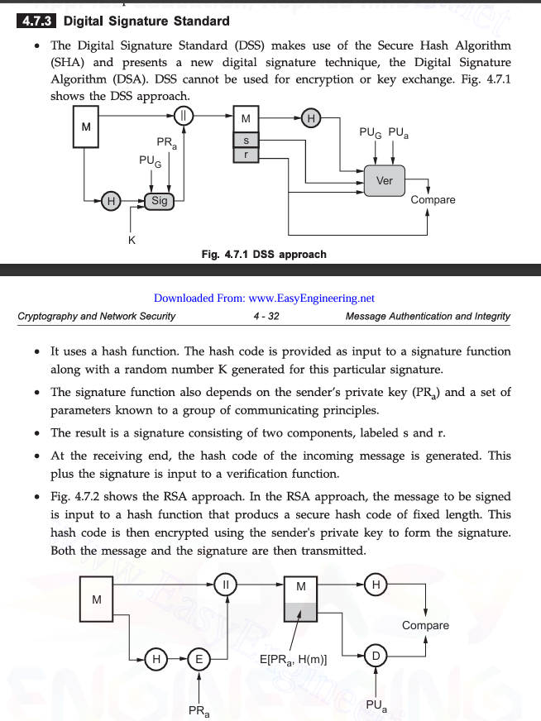
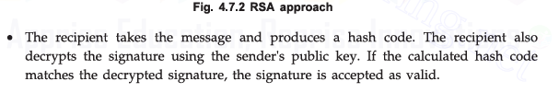

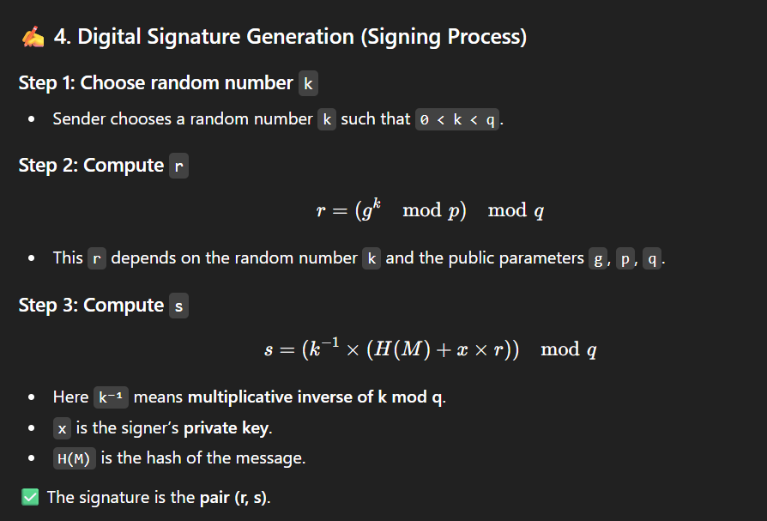
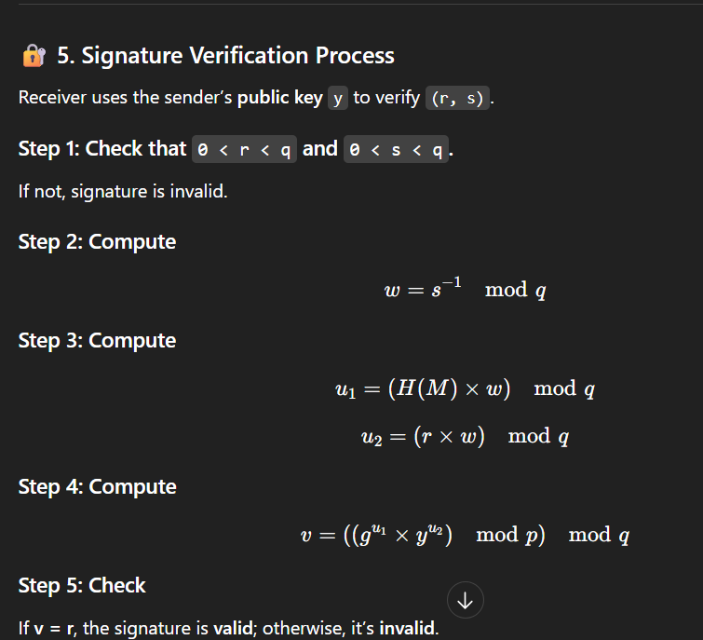
Kerberos Authentication Protocol – Detailed Explanation
Kerberos is a network authentication protocol developed by MIT that uses symmetric key cryptography to provide secure authentication over insecure networks. It prevents eavesdropping, replay attacks, and impersonation by using encrypted tickets instead of plain passwords. The protocol is based on the concept of a trusted third party called the Key Distribution Center (KDC).

Main Components
- Authentication Server (AS) –
This server verifies the identity of a user during initial login. It checks whether the user is legitimate and issues a Ticket Granting Ticket (TGT) if successful.
- Ticket Granting Server (TGS) –
This server provides service tickets to users who already have a valid TGT. The service ticket allows the user to access a particular network service securely.
- Service Server (SS) –
The service server hosts the requested application or resource (for example, a file server, email server, or database). It verifies the service ticket before granting access.
- Key Distribution Center (KDC) –
The KDC is a combination of the AS and TGS. It is trusted by all users and services in the network and securely stores the secret keys of all users and servers.

Keys Used
- Kc – Secret key derived from the user’s password.
- K_tgs – Secret key shared between the TGS and the KDC.
- K_v – Secret key shared between the service server and the KDC.
- Session keys (K_c,tgs, K_c,v) – Temporary keys used for communication between client and TGS, and between client and service server respectively.
For additional refer gfg

